TYPES OF BANKS IN US

In the United States, banks can be categorized based on their functions, ownership, and scope of operations:

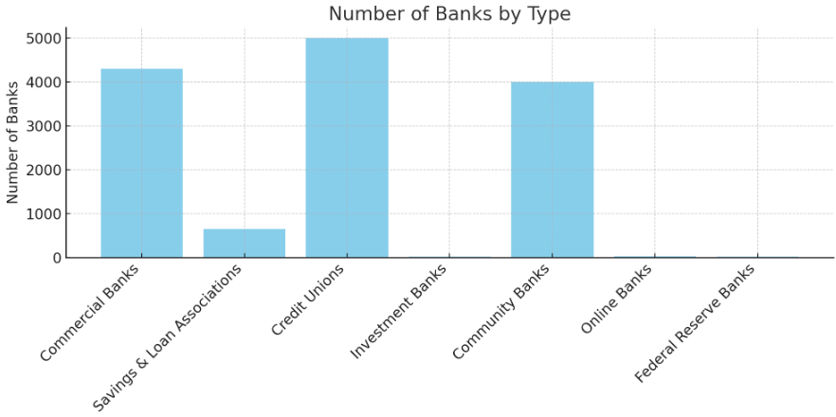

* Commercial Banks: 4,300
* Savings & Loan Associations: 650
* Credit Unions: 5,000
* Investment Banks: 15
* Community Banks: 4,000
* Online Banks: 30
* Federal Reserve Banks: 12

**1. Commercial Banks**

**Functions:**

* Accepting deposits from individuals and businesses.
* Providing loans and credit facilities.
* Offering financial services such as checking and savings accounts.
* Facilitating payment processing and fund transfers.

**Loopholes:**

* **Fractional Reserve Banking:** Allows banks to lend out a portion of depositor funds, which can lead to liquidity issues in times of financial stress.
* **Regulatory Arbitrage:** Banks may engage in practices to take advantage of differences in regulations across jurisdictions.

**2. Savings and Loan Associations (Thrifts)**

**Functions:**

* Specialize in accepting savings deposits and making mortgage and other loans.
* Focus on residential mortgage lending.

**Loopholes:**

* **Regulatory Capture:** Historically, some savings and loans were involved in risky real estate lending practices that led to significant losses and bailouts.
* **Interest Rate Risk:** Exposure to fluctuations in interest rates can impact their stability, as their assets (mortgages) often have long-term fixed rates.

**3. Credit Unions**

**Functions:**

* Member-owned financial cooperatives.
* Provide similar services as commercial banks, including deposits, loans, and financial services.
* Focus on serving their members, often with lower fees and better interest rates.

**Loopholes:**

* **Field of Membership:** Some credit unions may stretch their membership criteria to expand their customer base.
* **Lack of Diversification:** Smaller credit unions might face higher risk due to less diversified loan portfolios.

**4. Investment Banks**

**Functions:**

* Assist companies in raising capital through underwriting and issuing securities.
* Provide advisory services for mergers, acquisitions, and other financial transactions.
* Engage in trading and market-making activities.

**Loopholes:**

* **Conflict of Interest:** Investment banks may face conflicts of interest between their advisory and trading activities.
* **High Leverage:** Use of high leverage can amplify losses, contributing to financial instability.

**5. Community Banks**

**Functions:**

* Focus on serving the local community.
* Provide traditional banking services such as deposits and loans.
* Often more involved in local development projects.

**Loopholes:**

* **Limited Resources:** Smaller size may limit their ability to absorb financial shocks.
* **Concentration Risk:** Higher exposure to local economic conditions can impact stability.

**6. Online Banks**

**Functions:**

* Operate without physical branches, providing services exclusively online.
* Offer competitive rates and lower fees due to reduced overhead costs.
* Provide traditional banking services like deposits, loans, and payments.

**Loopholes:**

* **Cybersecurity Risks:** Increased risk of cyber-attacks and data breaches.
* **Regulatory Challenges:** May face difficulties in complying with diverse regulatory requirements across states.

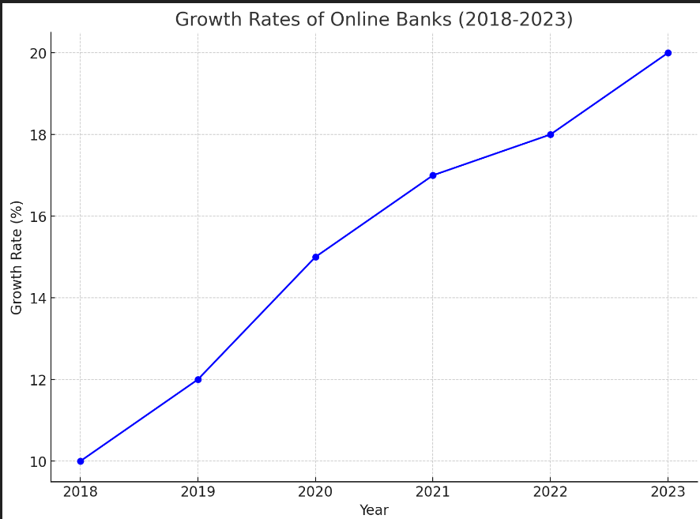

**7. Federal Reserve Banks**

**Functions:**

* Serve as the central bank of the United States.
* Implement monetary policy.
* Supervise and regulate member banks.
* Provide financial services to the government and financial institutions.

**Loopholes:**

* **Independence vs. Accountability:** Balancing independence with accountability and transparency can be challenging.
* **Policy Impact:** Unintended consequences of monetary policy actions can affect financial markets and the economy.

1. **Total Assets by Bank Type (in Trillions USD):**

* Commercial Banks: $23 trillion
* Savings & Loan Associations: $1 trillion
* Credit Unions: $2 trillion
* Investment Banks: $1 trillion
* Community Banks: $1 trillion
* Online Banks: $0.5 trillion
* Federal Reserve Banks: $8 trillion

1. **Average Loan-to-Deposit Ratios by Bank Type:**

* Commercial Banks: 75%
* Savings & Loan Associations: 85%
* Credit Unions: 70%
* Investment Banks: 60%
* Community Banks: 80%
* Online Banks: 50%
* Federal Reserve Banks: 100%

